L

Lifeline dATABASE

PYTHON PROJECT



Name:Ankit Shukla

Enroll no:141179 Batch:BX(B1)

**ACKNOWLEDGEMENT**

The completion of this undertaking could not have been possible without the participation and assistance of so many people whose names may not all be enumerated. Their contributions are sincerely appreciated and gratefully acknowledged. However, I would like to express their deep appreciation and indebtedness particularly to the following:

I would like to thanks Dr Mahesh Kumar who taught us Python language from basics and always welcome feedback for better environment for study

To all relatives, friends and others who in one way or another shared their support, either morally, financially and physically, thank you.

Above all, to the Great Almighty, the author of knowledge and wisdom, for his countless love.

We thank you.

**username-123**

**password-123**

**used by user to log in this software**

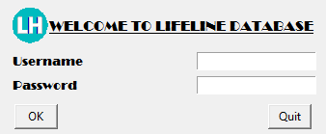

Fig 1-login window

This window accept username & password, on clicking on “ok” button

Application check whether username & password are correct or not

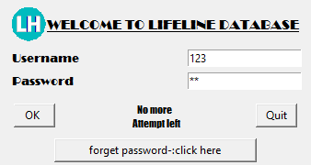

Fig 2 -login window when username or password wrong

More than 3 time

This appear window when in window appearing in fig 1 username or password entered

Are wrong more than 3 times

In this window “OK” button is disable to avoid more attempt by user

On clicking on “forget password” application open a website from user can get its

Username or password

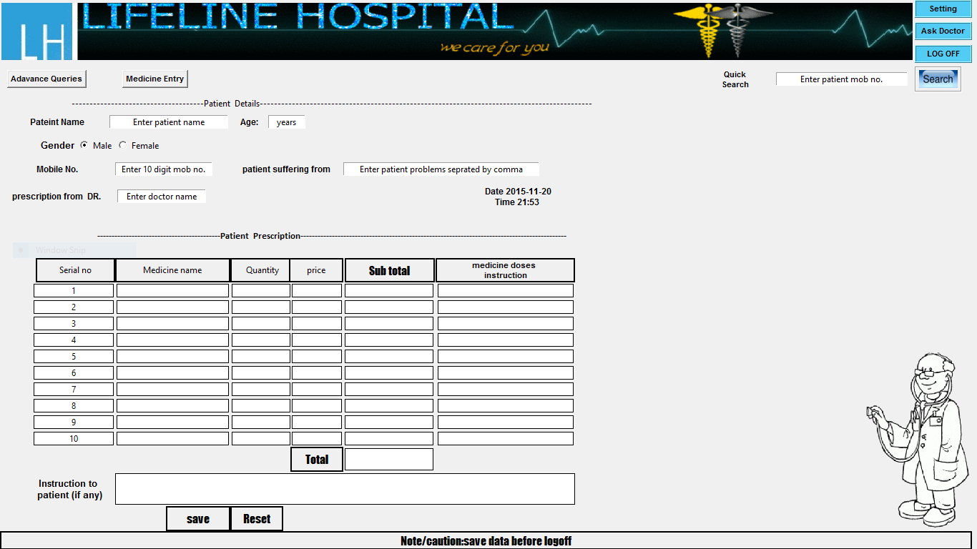

Fig3-home window

This is the home of application where user all entry related to patient & medicine

Also fetch result on the basis of query on search box

This home window have many part all those will be explain in detail

In upcoming pages

**Home window have 3 major part**

**1. Patient Entry**

**2. Patient prescription Entry**

**3. Search Box**

Patient Entry-Detail

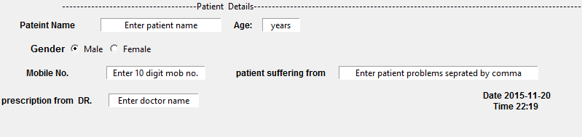

Fig4-: patient Entry part of home window

Patient entry of home window accept value of patient of hospital in the provided entry box

After entering data in entry box on clicking “TAB” button data of entry box is validate and pop a window if data is not appropriate for Database like

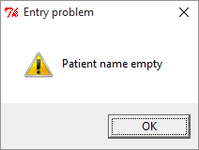

Fig5-: warning window

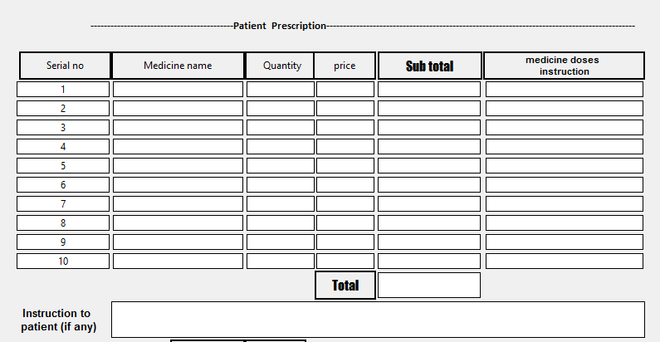**Patient prescription Entry**

**Fig 6 -: patient prescription Entry (without entry)**

* Patient prescription part of home window accept data of medicine

Name, Quantity etc.

* price, subtotal, total value will be initialised with the help of lifeline database

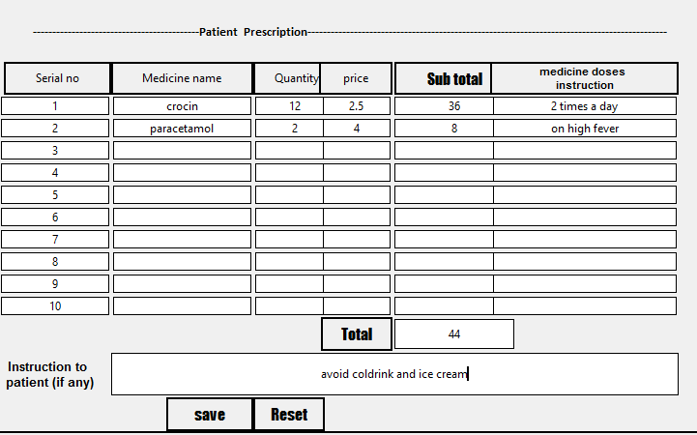

**Fig 7 -: patient prescription Entry (with entry)**

* On clicking on “Reset “button all inserted entry will be deleted.
* on clicking on “SAVE” button all data entry will be save in lifeline database from

which data can retrieve for future use & reset also

search-Detail

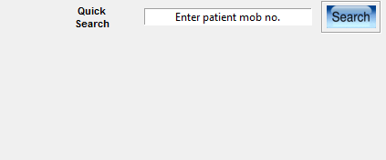

**Fig 8 -: search Box (without entry)**

* entry box accept 10 digit mobile
* search is a button on pressing it patient detail will be shown to user corresponding to number insert in it

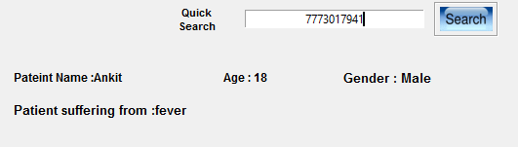

**Fig 9 -: search Box (without entry)**

* on clicking on ‘’reset” detail will be clear
* on clicking on ‘’ Search” patient info show below entry box

& if no patient info found respective mobile no in lifeline database

A window popup as given below

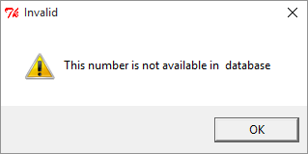

**Fig 9 -: search Box - Warning**

* **it show that no such mobile no exist in lifeline database**

--------------------------------------------------------------------------------------------------------------------------------------

**setting window**

--------------------------------------------------------------------------------------------------------------------------------------

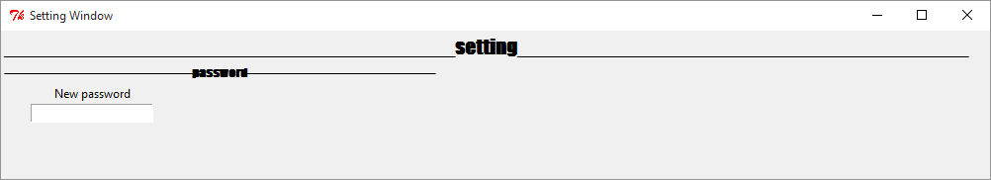

**Fig 10 -: setting window**

* **this window open on clicking on setting button of home window of**

**Lifeline application**

* **this window accept password from user to change login password for next login time**
* **clicking on Save button save password**
* **discard on close setting window**

**----------------------------------------------------------------------------------------------------**

**Medicine Entry window**

**------------------------------------------------------------------------------------------------------**

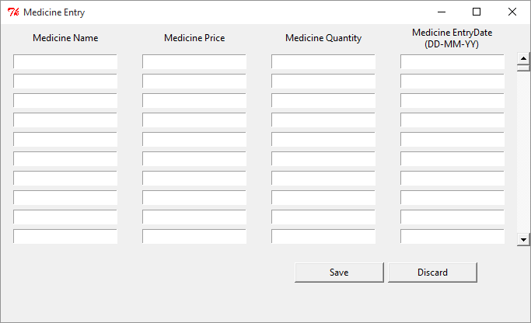

**Fig 11 -: medicine Entry window**

* **window accept medicine name ,price, quantity, entrydate**
* **this window open on clicking on medicine entry button**
* **scrollbar use by use to scroll row medicine entry**
* **clicking on Save button save data entry**
* **discard on close setting window**

**----------------------------------------------------------------------------------------------------**

**About us window**

**-----------------------------------------------------------------------------------------------------**

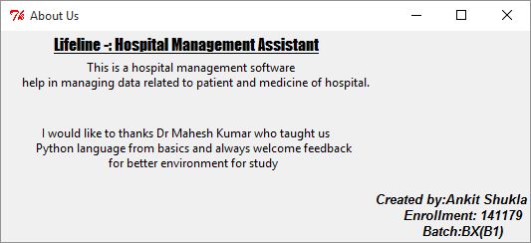

**Fig 12 -: About us window**

* **this window open on clicking on About us button**
* **in this window creator explain about project**
* **creator introduce himself**

**Resources**

* **lab exercise by DR Mahesh Kumar**
* **think python by Allen b downey**
* [**http://www.python-course.eu/index.php**](http://www.python-course.eu/index.php)
* [**https://docs.python.org/2.7/py-modindex.html**](https://docs.python.org/2.7/py-modindex.html)
* [**http://zetcode.com/db/sqlitepythontutorial/**](http://zetcode.com/db/sqlitepythontutorial/)
* [**http://pythonprogramming.net/dashboard/**](http://pythonprogramming.net/dashboard/)